Impacts of COVID-19 on Movie Theatre Industry
Affiliation
Professor
Student
Date

Impacts of COVID-19 on Movie Theatre Industry
Report Overview
The closure of essential industries and economic fallout that has been witnessed globally shows the unprecedented effects of the Coronavirus pandemic. Many industries are at the brink of total shut down or even filling bankruptcies. However, the movie theatre industry has not been spared and it’s also facing devastating challenges. Cinema theatres have been closed as a measure to prevent the spread of COVID-19. As a result, this industry has incurred a significance loss in revenue as compared to pre-COVID period. Many of the staff working in movies theatres were furloughed since early this year and other workers have been laid off. The purpose of this report is to analyse how Coronavirus outbreak has impacted the film production sector. Understanding of the impacts would be vital in creating a suitable framework to help various film production companies recover and gain resilience during this pandemic period.
Movie Theatre Industry Overview
The main objective of theatre companies is ensure all the seats get filled in most of the seasons in a year. In the previous years, the global cinema theatre industry showed healthy progress, with a consistently growing revenue for world-wide box office. The annual revenue generated by world-wide box office in 2019 was estimated to be more than 42 billion U.S. dollars. In 2019, the revenue generated from movie ticket sales was more than 1 billion U.S. dollars and cinema theatres remained busy. Audience in the age bracket of 25 to 39 made up the highest percentage in the movie theatres, (Sarah, 2020). The American Movie Classics (AMC) theatres was the leading cinema theatre with the highest ticket sales and number of audience the U.S. and Canada.
The theatre industries has always experienced significant growth due to release of blockbuster films which influence moviegoers to watch the movies from the theatres. This has led to high per capita income annually for the theatre industry and high revenues. Continuous upgrades and investments by the theatre industry has given it a competitive advantage against online file viewing platforms.
Industry-wide COVID-19 Impact
The ongoing pandemic has been the result of fear and uncertainty by cinema theatres. Although the government has lifted some measures that had been put in place to prevent the spread of Coronavirus, movie and cinema theatres have remained empty thus posing a great risk on the future of the industry. First of all, the outbreak of Coronavirus has triggered a high level of competition from online platforms for viewing movies against cinema theatres. The closure of movie theatres and restrictions to stay at home has seen people shift their interest towards online platforms to watch movies at home. Streaming platforms such as Amazon Prime and Netflix have experienced an increase in subscription as a result of cinema closure. This fosters the question whether the opening of movie theatres will attract as many audience as in the past or many people will have shifted their preference to watching movies online. Therefore, the outbreak of the Coronavirus disease has greatly impacted the cinema theatres and has made their future unknown.
Below is an image showing the change in preference on watching movies by people as a result of COVID-19.

Another overwhelming effect of COVID-19 on the movie theatres is the tremendous loss of revenue by box offices world-wide. The movie theatre industry is dependent on the production sector to film new movies. However, the ongoing pandemic has forced the production industry to postpone or cancel the release dates of various movies thus the theatres are not able to show any new movies. For instance, ‘No Time to Die’ by James Bond was pushed towards the end of the year. Before the closure of movie theatres, the revenue collected from ticket sales in movie theatres declined significantly with social distancing rules to prevent the spread of the virus. Movie theatres were only allowed to accommodate half the usual number of audience. With rapid increase in the rate of infections, they were shut down hence no revenue is currently being generated by world-wide box office from movie theatre ticket sales.
While the movie theatres are totally closed, the government intervenes by offering a certain amount of funding to keep them afloat. However, if the theatres are partially opened, they do not receive any funding from the government and have to depend on their revenue. With the measures to reduce the spread of COVID-19, the movie theatres will need to ensure social distancing thus cutting number of audience by nearly half. The amount of revenue generated from the sale of such tickets would not be sufficient to pay the staff and keep the industry stable. As a result, some staff will be furloughed and the remaining staff will be forced to perform extra tasks. Therefore, this would lead to unemployment and financial instability within the industry.
COVID-19 has also had a great impact on drive-in movie theatres. Although drive-in movie theatres have had a reduced popularity over time, they have an advantage of allowing viewers to watch the movie in the theatres from the safety of their car, (Evan, 2020). As a result of COVID-19 outbreak, drive-in theatres now reserve two parking slots for one car to maintain social distance. This has enabled them to gain popularity again since customer can order concession online to avoid queues. This has left the movie theatres empty as illustrated in the picture below.

The exact fate of cinema theatres is currently unknown. Experts believe that even upon reopening of movie theatres, things will not be same again like the pre-COVID times. There will be increased protocols and safety measures such as social distancing rules. This will result to an increase in price of tickets due to reduced number of audience. Consequently, people might be unwilling to pay the higher prices and may stream movies from online platforms at the comfort of their homes. Even after reopening, the people are likely to develop the fear of going to a movie theatre breathing recirculated air for the period they are there. Many of them will not take any risks that are likely to lead to Coronavirus infection. This is devastating for the cinema industry after facing a 5% per capita decline in consumption.
The Coronavirus pandemic has led to distress among exhibitors. Most businesses with thin margins and enormous leases can withstand a few months without revenue. However, the government has put in place policies to bailout and support major exhibitors with loans during the shutdown. This means that movie theatres will focus on cost saving projects such as reduced theatre upgrades and shutting down less popular theatres. Therefore, people will need to travel further to watch a movie since only the most popular ones will be opened.
Impact of COVID-19 on Specific Companies
The AMC theatres has expressed their concerns of being understaffed due to lack of revenue to maintain its staff. Earlier in the year when theatres were partially opened, AMC revenues accrued to 1.3 billion U.S. dollars with a net loss of 54 million U.S. dollars. The AMC theatres have remained partially opened over the year thus no enough income to maintain its projects and to pay the staff. Although it announced plans to reopen fully, there were claims that it is in the verge of bankruptcy due to the high capacity of debts. Towards the end of October, the AMC theatres were operating at approximately 300 locations internationally, (Sarah, 2020). However, it was noticed that people were less reluctant to turn up for the cinemas as long as the virus was not under control.
Regal theatres temporarily closed their operations in October this year due to the Coronavirus effects. This resulted to temporarily laying off more than 45,000 employees from all its locations. This has created a high level of uncertainty not only in Regal theatres but also all the other cinema theatre industries.
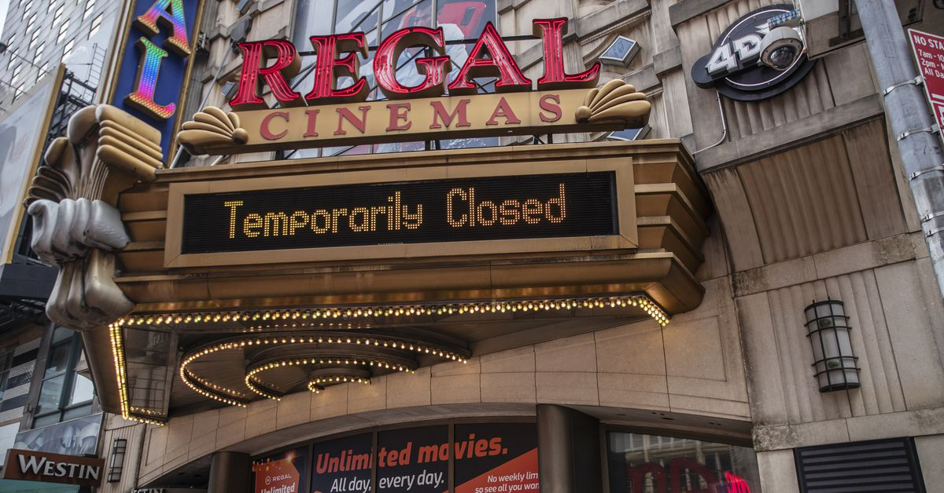
Below is a screenshot of a video explaining briefly the impacts of COVID-19 on movie theatre industry.

Conclusion
The cinema theatre industry has been made vulnerable by the outbreak of COVID-19. Restrictions to avoid the spread of the virus have been a major challenge for the movie theatre business. The policies by the government to open partially and reduce number of audience in theatres has contributed to the low revenue in the industry. As a result, weaker companies have been destabilized leading to bankruptcies, employee layoff, and complete shutdown. Many movie theatre companies have plans for reopening, with the government issuing the guidelines to be followed to prevent spread of Coronavirus disease. However, this industry may be faced with competition from the modern technology of live streaming through Netflix or Amazon Prime platforms. Financial instability is a likely possibility in the cinema world due to the constantly increasing ticket prices and reduced audience. Ultimately, the future of this industry is all up in the air and is dependent on the persistence of the virus. If a vaccine to the virus is realized early enough, then hope remains for the revival of the movie theatre industry.

References
Sarah K., (2020). Ron Howard. The Movie Thaetre Industry is going No Away. https://www.cnbc.com/2020/10/01/ron-howard-the-movie-theater-industry-is-not-going-away.html#:~:text=public%20indoor%20spaces.-,In%202019%2C%20the%20domestic%20box%20office%20reported%20%2411.4%20billion%20in,than%20%248.4%20billion%20in%20sales.
Mounir J, (2020). Covid 19 Effects to the Cenema Industry. https://www.insidetelecom.com/covid-19-effects-on-the-cinema-industry/
Evan K., (2020). The Impact of Covid-19 on Movie Theaters. https://movies.mxdwn.com/feature/the-impact-of-covid-19-on-movie-theaters/
https://www.statista.com/topics/964/film/#dossierSummary__chapter4
https://www.matthewball.vc/all/covidmovies
https://www.youtube.com/watch?v=RvLNqCaQNvc
Sarah W., (2020). Coronavirus Movie Industry Studios Move Blockbusters Audiences Stay Home. Brent L., (2020). Covid-19 Brutalizes AMC Thaetres Quaterly Earnings, Losses Top $900 Million.

